~Asia-Japan-Mirror-Edo-Lion and Grapes

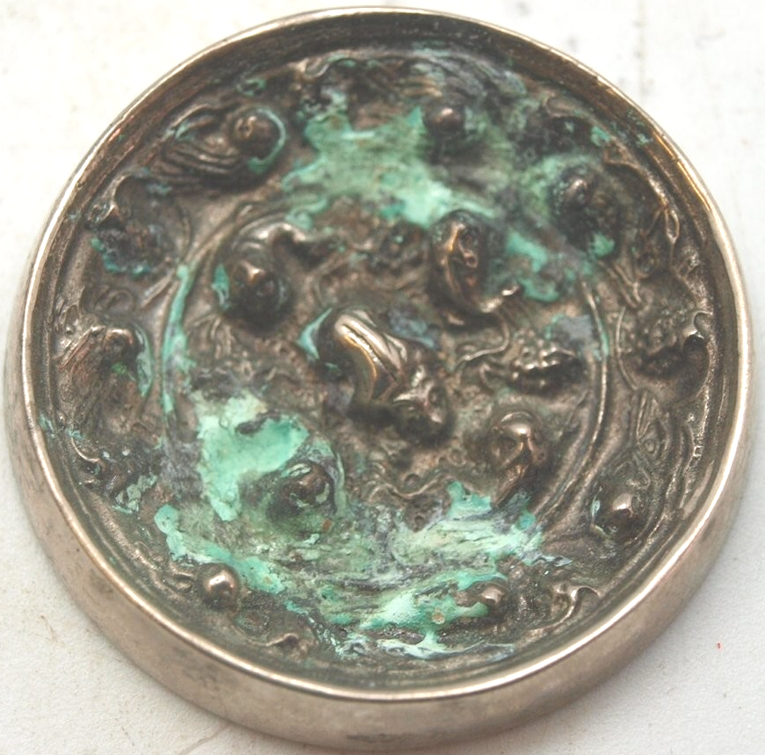

Bronze Japanese mirror measuring 38mm in diameter.  This bronze mirror is silver plated, but has been heavily tarnished.  The back is decorated with primitive scenes of oriental creatures and possibly fish.  It has a central boss which is pierced to allow a cord to be passed through for holding.  The other side is undecorated and would have originally been polished to create a reflective surface.